24-10-2023

Francisco David Martin Reguero

nuevo desglose ies campanillas

UD 1 Actividad 4

Sistemas Informáticos

**1. PCB (Printed Circuit Board)**

The PCB is the establishment of a motherboard, giving electrical associations between components. It houses the CPU, memory, and other basic equipment components.

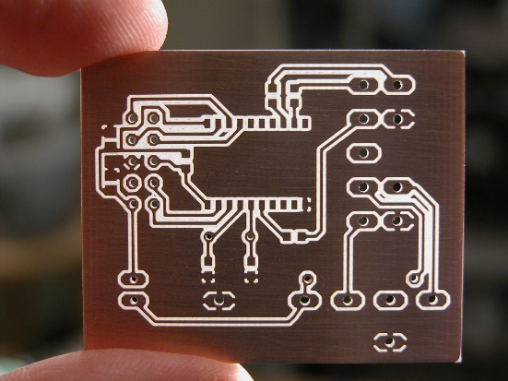

**2. Oscillator (Xtal)**

The oscillator, frequently alluded to as Xtal, creates clock signals for the motherboard and synchronizes different components' operations.

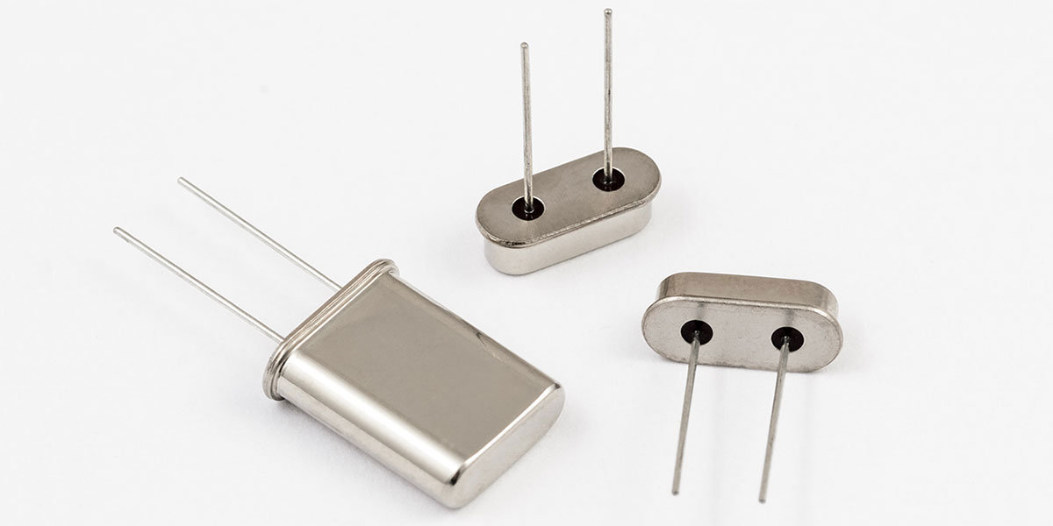

**3. VRM (Voltage Controller Module)**

VRM controls the voltage provided to the CPU, guaranteeing steady and effective control conveyance to the processor.

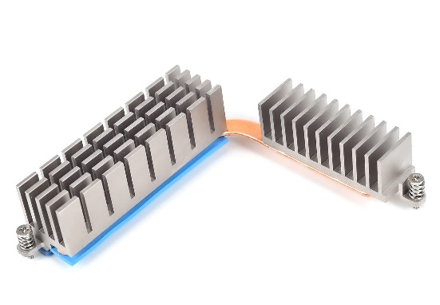

**4. Coordinates Sound (Sonido Integrado)**

Coordinates sound alludes to the onboard sound controller that permits the motherboard to deliver sound without the require for a partitioned sound card.

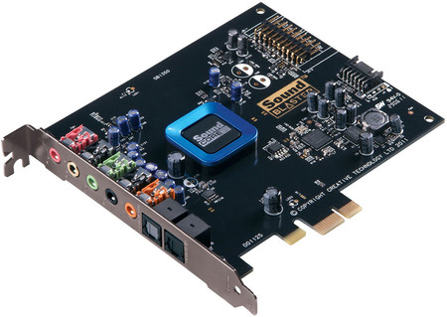

**5. Coordinates NIC (Adaptador de Ruddy Integrado)**

Coordinates Arrange Interface Card gives onboard organizing capabilities, empowering the motherboard to put through to systems without an extra arrange card.

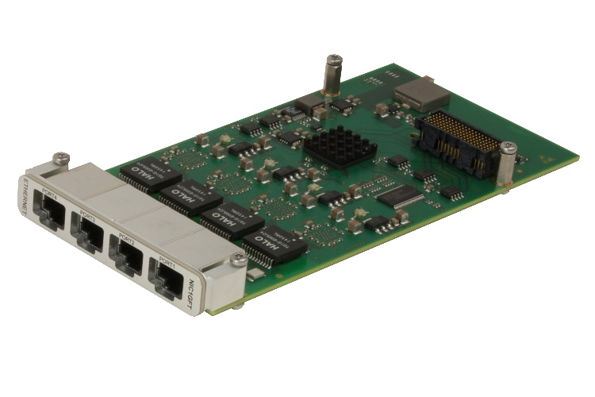

**6. Chipset**

The chipset oversees information stream between the CPU, memory, capacity, and peripherals. It plays a vital part in deciding the motherboard's capabilities.

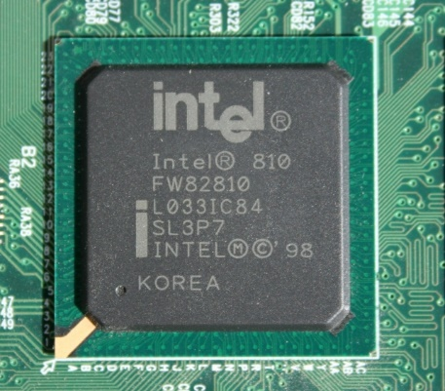

**7. Onboard Cooling (Refrigeración On-Board)**

Onboard cooling frameworks incorporate heatsinks, warm channels, and fans coordinates into the motherboard to disseminate warm from components just like the CPU and chipset.

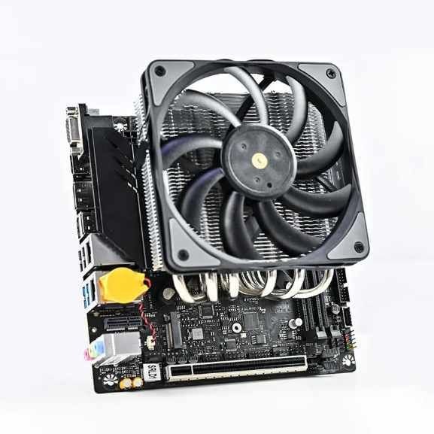

**8. Extension Spaces (Ranuras de Expansión)**

Development openings permit clients to include extra equipment components, such as design cards, sound cards, and organize cards, to the motherboard.

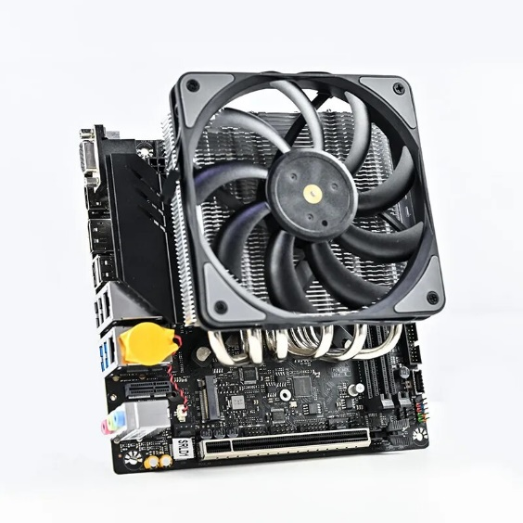

**9. Slam Opening DIMM**

Slam spaces, too known as DIMM openings, hold the system's memory modules, permitting the computer to get to information rapidly.

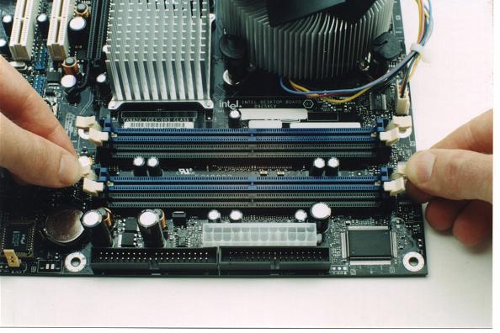

**10. CPU Attachments (Attachments de la CPU)**

CPU attachments are connectors on the motherboard that hold the processor, building up the association between the CPU and the motherboard.

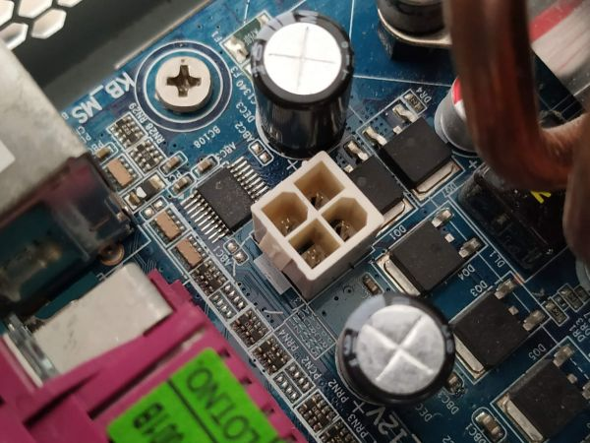

**11. CMOS Battery**

The CMOS battery powers the CMOS (Complementary Metal-Oxide Semiconductor) chip, protecting framework settings and the framework clock indeed when the computer is fueled off.

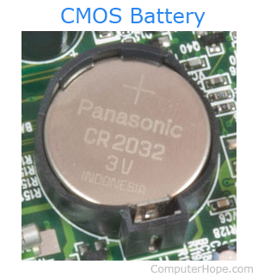

**12. RTC Chip (Real-Time Clock Chip)**

The RTC chip keeps up the real-time clock and calendar capacities, guaranteeing precise timekeeping for the framework.

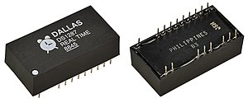

**13. E/S Ports (Puertos E/S)**

E/S (Input/Output) ports are connectors on the motherboard for outside gadgets like USB, HDMI, Ethernet, and sound jacks.

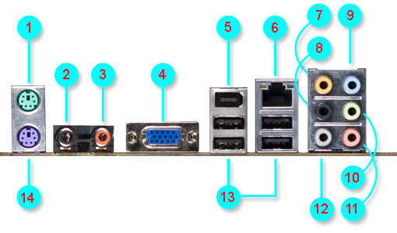

**14. Onboard LED/Display**

Onboard LEDs or shows give visual input almost the motherboard's status, such as control supply, boot codes, and blunder messages.

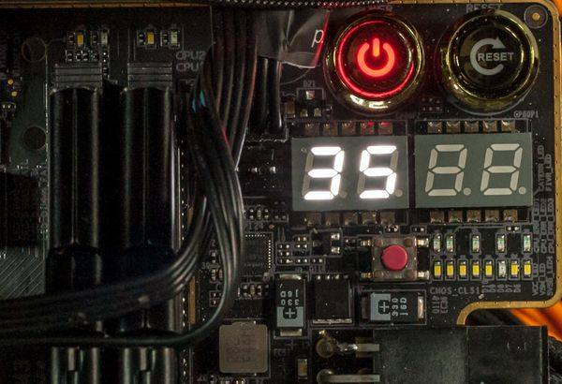

**15. Framework Board Connector Header (Cabezal de Conectores del Board del Sistema)**

The framework board connector header may be a cluster of pins on the motherboard that interfaces to the computer case's control button, reset button, LEDs, and other front-panel capacities.

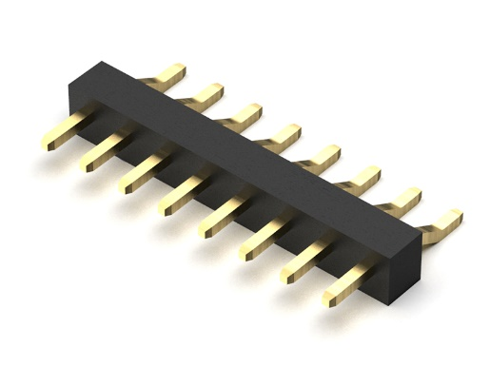

**16. Clear CMOS Jumper**

The clear CMOS jumper may be a physical switch that, when actuated, resets the BIOS settings to default, valuable for investigating and framework recuperation.

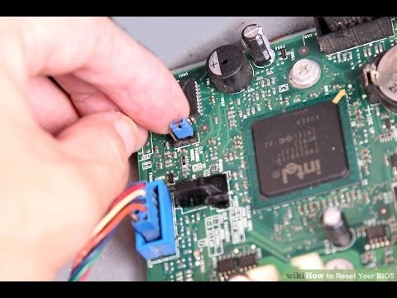

**17. Super I/O**

Super I/O (Input/Output) chip controls different I/O capacities on the motherboard, counting serial and parallelports, temperature sensors, and fan speed control.

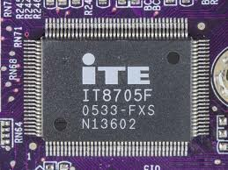

**18. Mounting Gaps (Agujero de Montaje)**

Mounting gaps on the motherboard permit it to be safely connected to the computer case, guaranteeing solidness and appropriate component arrangement.

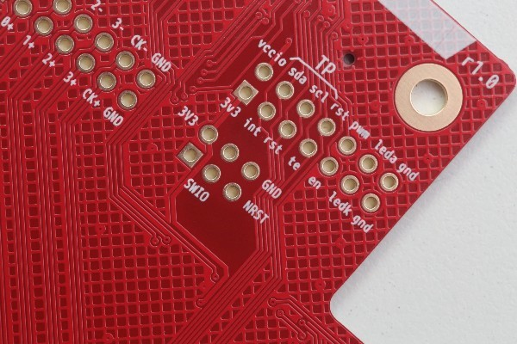

**19. Fan Connectors (Conectores de Ventiladores)**

Fan connectors give control and control for cooling fans, directing their speed and guaranteeing proficient cooling inside the framework.

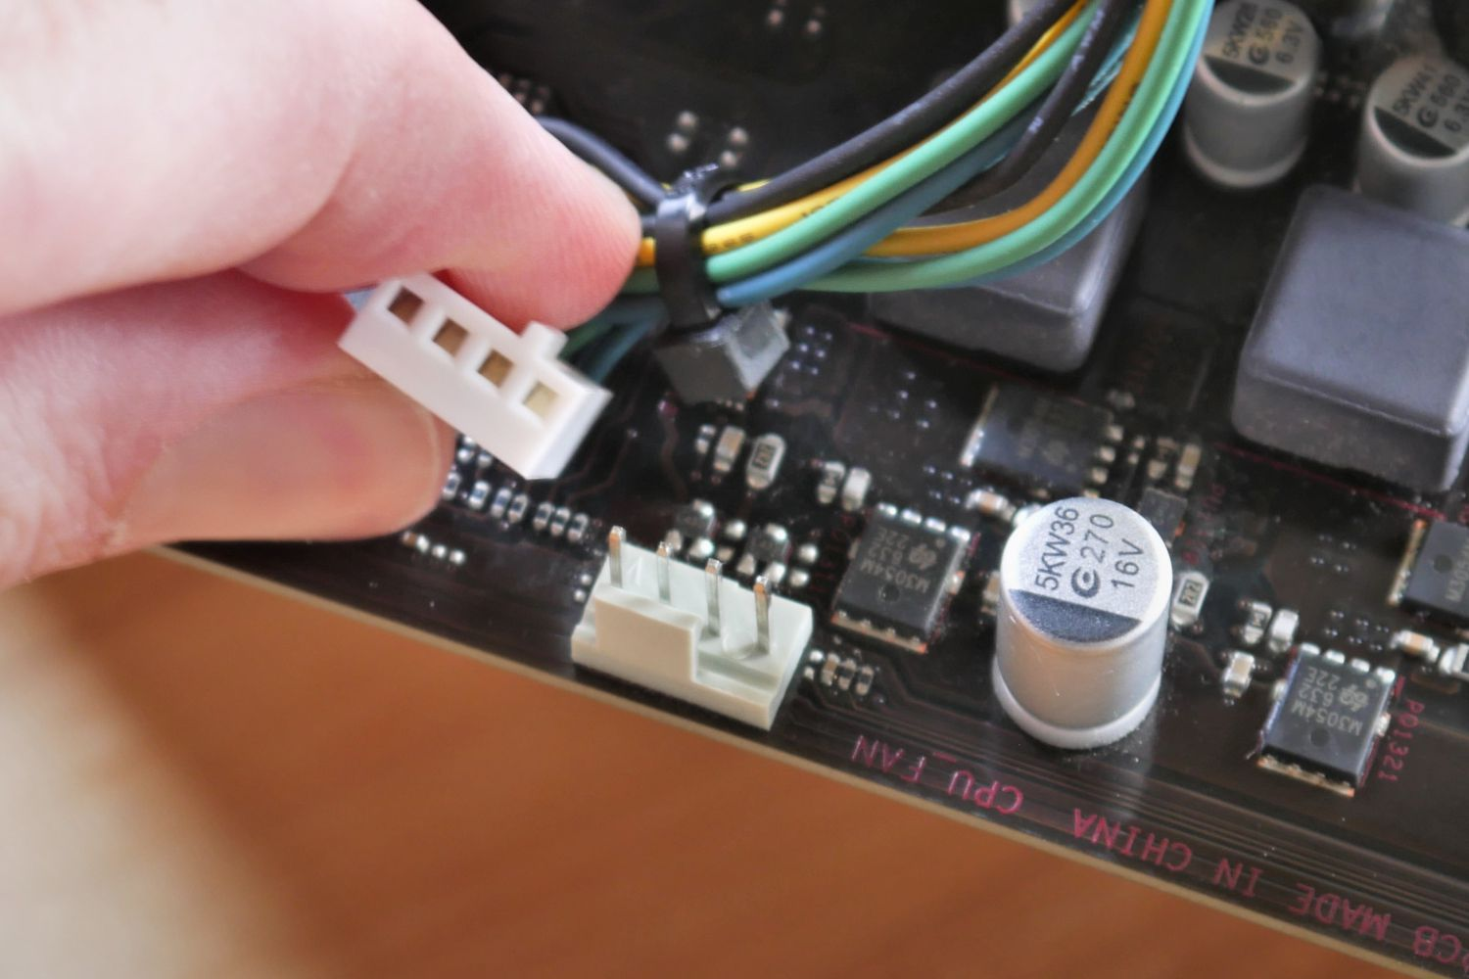

**20. Control Connectors (Conectores de Alimentación)**

Control connectors on the motherboard get control from the PSU (Control Supply Unit) and disseminate it to different components, guaranteeing they work accurately.

